

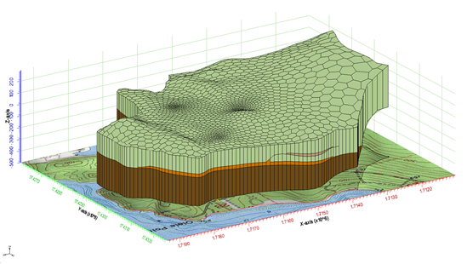

GMS 10.9

GMS 10.9 Tutorial

***MODFLOW-USG – Complex Stratigraphy***

Create a MODFLOW-USG model of a site with complex 3D stratigraphy using GMS

Objectives

GMS supports building MODFLOW-USG models with multiple types of unstructured grids. This tutorial shows how to generate 3D unstructured grids of complex stratigraphy.

Time

* 30–50 minutes

Required Components

* GMS Core
* Subsurface
* MODFLOW Interface

Prerequisite Tutorials

* Stratigraphy Modeling – Horizons and Solids
* MODFLOW – Conceptual Model Approach I
* UGrid Creation

|  |
| --- |
| 1 Introduction 2  1.1 Description of Problem 4  2 Getting Started 5  2.1 Open the Starting Project 5  2.2 Save with a Different Name 6  3 Quadtree UGrids 6  3.1 Create a 2D Quadtree UGrid 6  3.2 Create and View a 3D Quadtree UGrid 8  3.3 Create a MODFLOW-USG Model 10  3.4 Map to MODFLOW 11  3.5 Save and Run MODFLOW 12  4 Voronoi UGrids 13  4.1 Create the 2D Voronoi UGrid 13  4.2 Create a 3D Voronoi UGrid 14  4.3 Create a MODFLOW-USG Model 14  4.4 Map to MODFLOW 15  4.5 Save and Run MODFLOW 16  5 VTK Unstructured Grids 17  5.1 Import the VTK Unstructured Grid File 17  5.2 Create a 3D UGrid 18  5.3 Create a MODFLOW-USG Model 19  5.4 Map to MODFLOW 19  5.5 Save and Run MODFLOW 20  6 Conclusion 21 |

# Introduction

MODFLOW-USG (for UnStructured Grid) was developed to support a wide variety of structured and unstructured grid types, including nested grids and grids based on prismatic triangles, rectangles, hexagons, and other cell shapes. Flexibility in grid design can be used, for example, to focus resolution along rivers and around wells or to subdiscretize individual layers to better represent hydrostratigraphic units.

An extremely powerful feature is MODFLOW-USG’s subdiscretization capability to better represent hydrostratigraphic units. Traditional MODFLOW requires that grid layers be continuous throughout the model domain even if the particular stratigraphic unit ends or pinches out (see Figure 1).

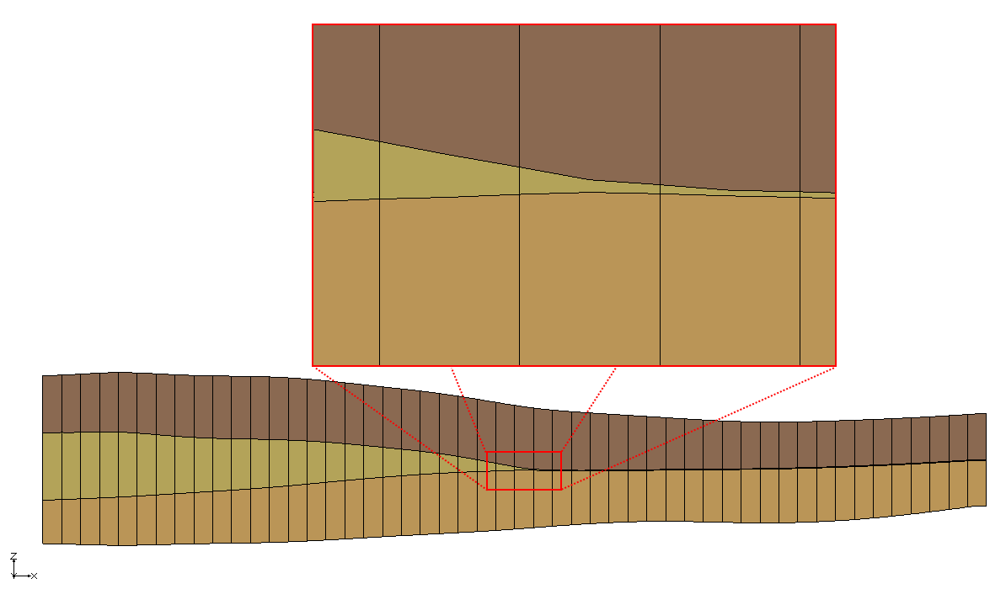

Figure 1 MODFLOW 2000 finite difference grid with pinching layer

With MODFLOW-USG, the grid layer can simply end. Figure 2 shows examples of complex gridding from the MODFLOW-USG documentation.[1]

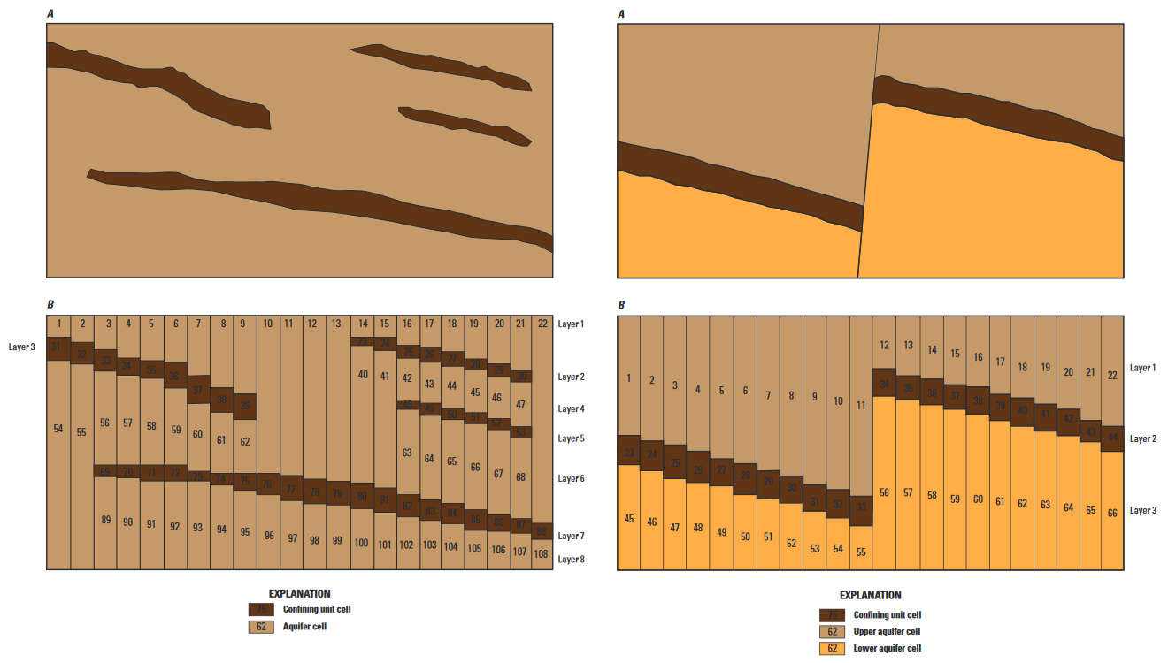

Figure 2 Complex stratigraphy examples

As seen from the figures, MODFLOW-USG allows layers to be discontinuous or even offset from one another. Figure 3 shows the same model as in Figure 1, created instead using a MODFLOW-USG compatible UGrid. Notice how the pinching layer is discontinuous and stops upon reaching a minimum thickness.

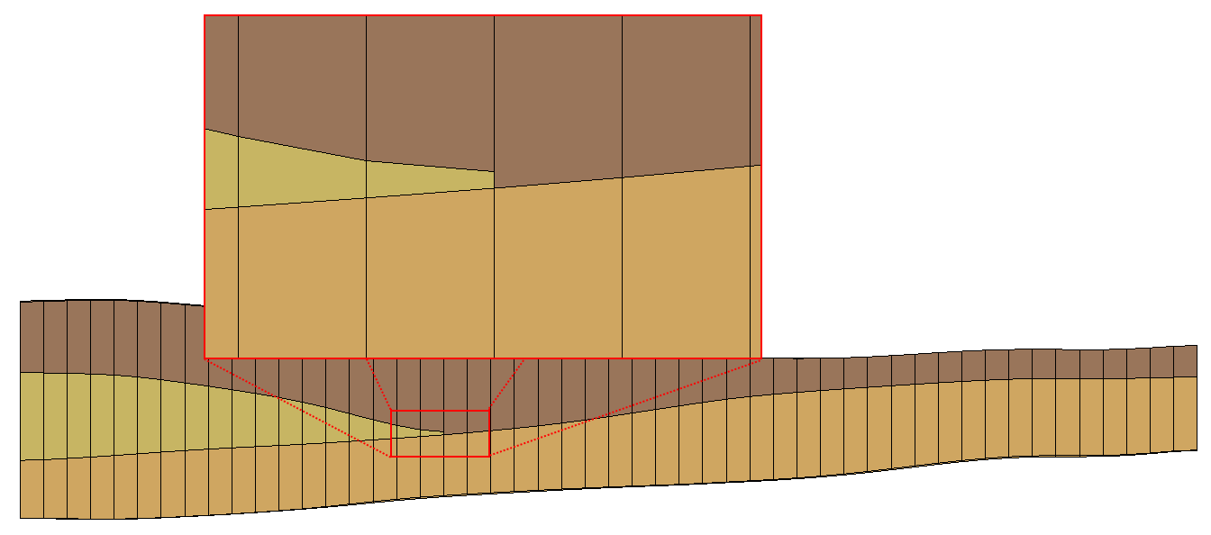

Figure 3 Example of a UGrid with pinching layer

This tutorial focuses on using the horizons approach in GMS to generate a 3D unstructured grid for complex stratigraphy. Using GMS, complex 3D unstructured grids can be quickly and easily generated from a variety of subsurface data, including boreholes, user-defined cross sections, TINs, rasters, and conceptual models.

## Description of Problem

The site to be modeled in this tutorial is a small coastal aquifer with three production wells (Figure 4). The no-flow boundary on the upper left corresponds to a parallel-flow boundary, and the no-flow boundary on the left corresponds to a thinning of the aquifer due to a high bedrock elevation. A stream provides a river boundary condition on the lower left, and the remaining boundary is a coastal boundary simulated with a specified head condition.

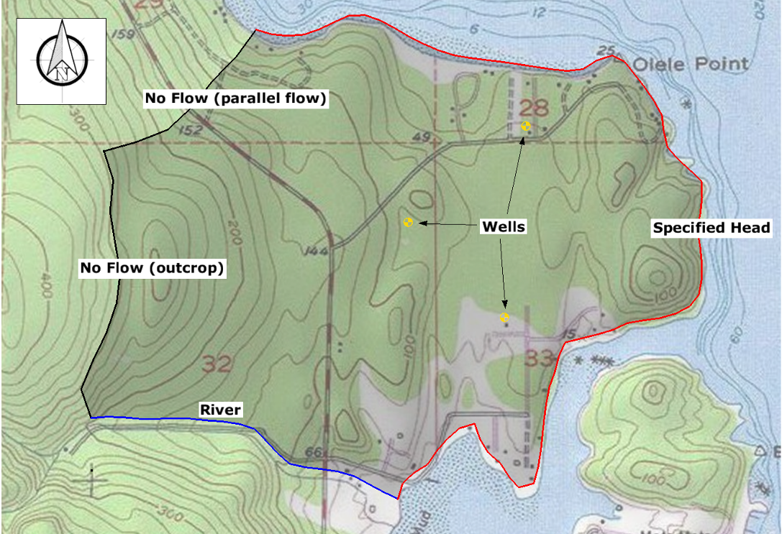

Figure 4 Site conceptual model

A fence diagram of the site is shown in Figure 5. The stratigraphy of the site consists of an upper and lower aquifer with minor semi-confining units with significantly lower hydraulic properties. The upper aquifer has a hydraulic conductivity of 10 feet per day and the lower aquifer has a hydraulic conductivity of 30 feet per day. The wells extend to the lower aquifer. The recharge to the aquifer is about one foot per year.

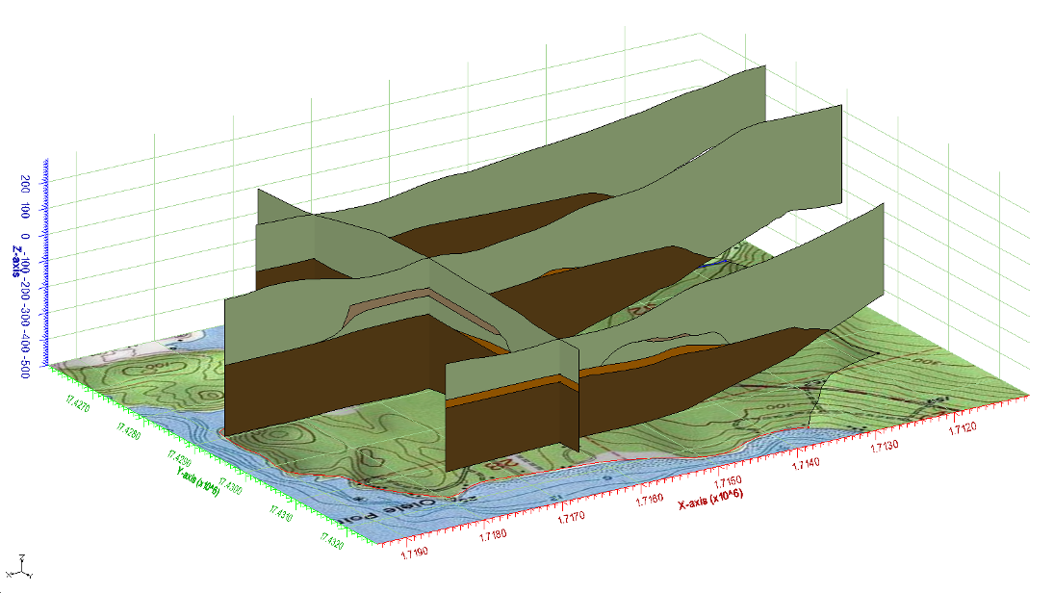

Figure 5 Fence diagram of site’s subsurface

This tutorial will discuss and demonstrate:

* Importing an existing GMS project.
* Generating 2D and 3D quadtree UGrids (the latter using the horizons method).
* Generating 2D and 3D Voronoi UGrids (the latter using the horizons method).
* Importing a VTK unstructured grid file.
* Generating a 3D UGrid using the horizons method.
* Mapping the model to MODFLOW.
* Running a simulation.

As shown above, this tutorial assumes an understanding of how to use the horizons method to create subsurface models and the conceptual modeling approach for assigning MODFLOW model properties. Therefore, the “Stratigraphy Modeling – Horizons and Solids” and the “MODFLOW – USG – Quadtree” tutorials should be completed prior to beginning this tutorial.

# Getting Started

Do the following to get started:

1. If necessary, launch GMS.
2. If GMS is already running, select *File |* **New** to ensure that the program settings are restored to their default state.

## Open the Starting Project

To open a GMS project that contains the shape files giving the model geometry:

1. Click **Open**  to bring up the *Open* dialog.
2. Select “Project Files (*.gpr)” from the *Files of type* drop-down.
3. Browse to the *ComplexStratigraphy\ComplexStratigraphy* directory and select “start.gpr”.
4. Click **Open** to import the project and exit the *Open* dialog.

The model should appear similar to Figure 6.

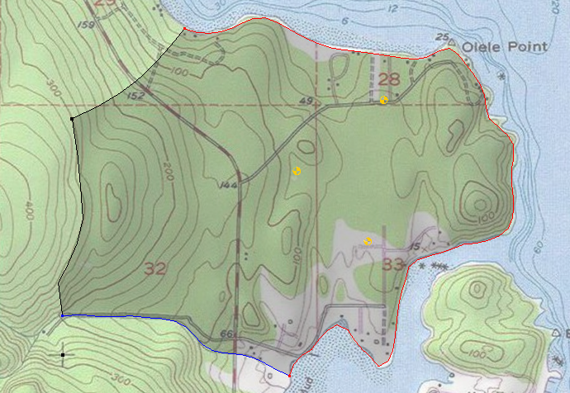

Figure 6 The imported model

## Save with a Different Name

Before making any changes, it is advised to save the project under a new name.

1. Select *File |* **Save As…** to bring up the *Save As* dialog.
2. Select “Project Files (*.gpr)” from the *Save as type* drop-down.
3. Enter “olele.gpr” as the *File name*.
4. Click **Save** to save the project under the new name and close the *Save As* dialog.

**Save**  the project periodically throughout the tutorial.

# Quadtree UGrids

## Create a 2D Quadtree UGrid

This project already contains a conceptual model of both map data and subsurface data. Therefore, this tutorial will start by generating the grid.

1. Right-click in a blank space in the Project Explorer and select *New* **| Grid Frame**.
2. Right-click on “ Grid Frame” and select **Fit to Active Coverage**.

This ensures the grid is big enough to include the site.

1. Right-click on “ Grid Frame” and select *Map To* **| UGrid** to open the *Map → UGrid* dialog.

To create a 2D quadtree grid with a base cell size of 500 ft, with finer resolution around the wells, river, and coastal boundary.

1. From the *Dimension* drop-down, select “2D”.
2. From the *Ugrid type* drop-down, select “Quadtree / Octree”.
3. In both the *X-Dimension* and *Y-Dimension* sections, select *Cell size* as the *Cell size method*.
4. Enter “500.0” as the *Cell size* in both sections.
5. Click **OK** to close the *Map → UGrid* dialog.

The new 2D UGrid should be similar to that in Figure 7. The large cells in the UGrid have a cell size of about 500 feet.[2]

1. **Zoom**  in around the wells, river, or coastal boundary to see the smaller cells.
2. When done, click the **Frame**  macro.

The size of the cells around the boundary conditions are specified in the “Refine” attributes of those boundary conditions.[3]

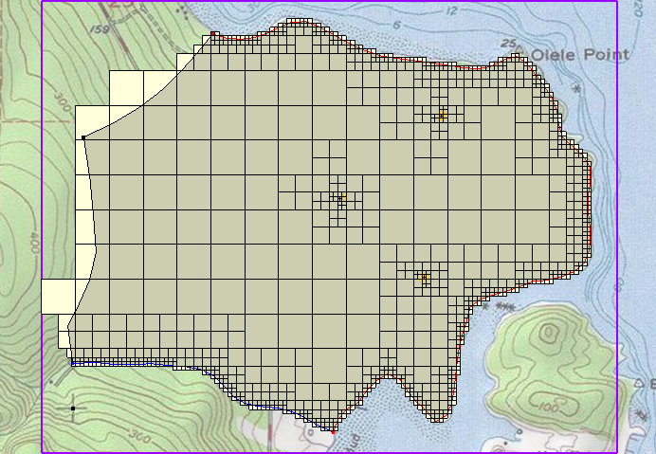

Figure 7 2D quadtree UGrid

To rename the UGrid that was just created:

1. Right-click on “ ugrid” and select **Rename**.
2. Enter “quadtree” and press *Enter* to set the new name.

## Create and View a 3D Quadtree UGrid

It is now possible to use the 2D quadtree UGrid and the subsurface data (boreholes, cross sections, and conceptual model) to create a 3D quadtree UGrid. If desired, explore the borehole and cross section data to see the current subsurface conceptual model. In the interest of time, the tutorial will not go through any of the steps to explore the subsurface data.

1. Turn off “ quadtree” in the Project Explorer.
2. In the Project Explorer, select “ Borehole Data” to make it active.
3. Select *Boreholes |* **Horizons → UGrid…**to bring up the *Horizon Elevations* page of the *Horizons to UGrid* dialog.

The data and the options used to generate the UGrid are selected here. In the first step of the wizard, the subsurface data to be used is specified. In this example, the borehole data, the user-defined cross sections, and the conceptual model will be used.

1. In the *Boreholes* section, turn on *Use boreholes* and *Use borehole cross sections*.
2. In the *Conceptual model* section, turn on *Use horizons conceptual model*.
3. Click **Next >** to go to the *Top and Bottom Elevations* page of the *Horizons to UGrid* dialog.

In this step, the 2D UGrid to be extruded into a 3D UGrid is selected. Since there is currently only one UGrid in the project, it is not necessary to change the selected *Primary UGrid*. However, the top and the bottom of the UGrid will need to be defined. In this case, there is a TIN that defines the ground surface of the site. The bottom of the boreholes will be used for the bottom of the UGrid.

1. In the *Top elevation* section, select the *TIN elevations* option.
2. Click **Next >** to go to the *Build UGrid* page of the *Horizons to UGrid* dialog.

This page of the dialog allows specifying the interpolation option (this tutorial will use the default) as well as various meshing options. The *Minimum element thickness* option ensures that all cells/elements in the UGrid have a thickness greater than or equal to the specified minimum.

1. In the *Meshing options* section, turn on *Minimum element thickness* and enter “2.0” in the field just below that.
2. Click **Finish** to exit the *Horizons to UGrid* dialog and create the 3D UGrid.

The 3D UGrid generation should complete quickly. To rename the new UGrid and view it in 3D:

1. Right-click on “ quadtree (2)” and select **Rename**.
2. Enter “quadtree-3d” and press *Enter* to set the new name.
3. Turn off “ Grid Frame” and “ Map Data” in the Project Explorer.
4. Switch to **Oblique View** .

The 3D UGrid should appear similar to Figure 8.

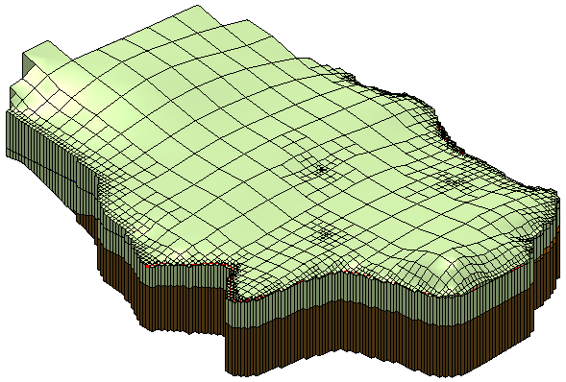

Figure 8 3D quadtree UGrid

To examine the properties of the newly created UGrid:

1. Uncheck “ quadtree” in the Project Explorer and select “ quadtree-3d” to make it active.
2. Right-click on “ quadtree-3d” and select **Properties…** to open the *UGrid Properties* dialog.

This dialog provides information on the extents of the UGrid. This includes the number of cells and nodes as well as the type of cells (2D/3D). There will be about 2,693 cells and 5,265 nodes.

1. Click **OK** to exit the *UGrid Properties* dialog.

It is now possible to view the five different layers of the UGrid. In the previous figure, the light green layer and the brown layer were clearly visible. These are layers 1 and 5 respectively. There are three other layers that are not as easy to see. Use the single layer viewing option to see the different layers of the UGrid. This option is found near the top of the GMS window.

1. Turn on *Single layer* in the *Mini Grid Toolbar* .

The view of the UGrid has now changed and only the cells in layer 1 are visible.

1. Change the *Layer* value to “2”.

The view of the UGrid should now look similar to the left side of Figure 9.

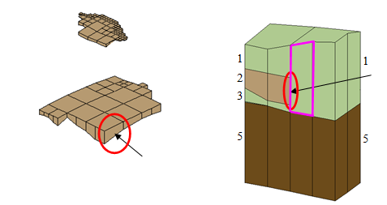

Figure 9 Layer 2 of 3D quadtree UGrid and side view cells

This layer represents two low permeability lenses at this site. These lenses are disjointed from one another, and they cover only a portion of the modeled site. This is an example of how a 3D UGrid supports discontinuous layers. Note that all of the cells in this layer have a thickness of at least two feet (this was part of the input to the **Horizons → UGrid** command). These lenses do not extend any further because any cells beyond the current extent would have had a thickness of less than two feet.

Notice the face of the circled cell face on the left side of Figure 9. This face is adjacent to another cell face in a different layer, as can be seen on the right side of the figure. The adjacent cell outlined in pink is in layer 1 but is adjacent to cells in layers 1, 2, and 3. Data regarding cell face adjacency and face areas is written in the DISU package. MODFLOW-USG uses the information in the DISU package to allow flow between these cells.

Feel free to review the other layers included in the UGrid by changing the *Layer* value. When finished, do the following:

1. Turn off *Single layer* in the *Mini Grid Toolbar*.
2. Switch to **Plan View** .

## Create a MODFLOW-USG Model

To create the MODFLOW-USG model:

1. Select *MODFLOW |* **New Simulation…** to bring up the *MODFLOW Global/Basic Package* dialog.

Notice in the dialog, under the *MODFLOW version* section, that the only version available is USG. This is because the MODFLOW simulation is being created on a UGrid. All of the other versions of MODFLOW can only be used on a structured 3D grid.

1. Click **OK** to accept the defaults and exit the *MODFLOW Global/Basic Package* dialog.

The aquifer properties also need to be defined. This example will use materials to assign aquifer properties.

1. Select *MODFLOW |* **LPF - Layer Property Flow…** to open the *LPF Package* dialog.
2. In the *Layer property entry method* section, select *Use material IDs*.
3. Click **OK** to exit the *LPF Package* dialog.

## Map to MODFLOW

To assign the conceptual model values to the MODFLOW model:

1. Right-click on the “ MODFLOW” conceptual model in the Project Explorer and select *Map To* **| MODFLOW/MODPATH** to bring up the *Map → Model* dialog.
2. Click **OK** to accept the defaults and close the *Map → Model* dialog.

Boundary condition symbols for specified heads, rivers, and wells should appear. To see the symbols better, it is possible to turn off the cell faces on the UGrid.

1. Right-click on “ UGrid Data” and select **Display Options…** to bring up the *Display Options* dialog.
2. Select “UGrid: quadtree-3d – [Active]” from the list on the left.
3. Click on *Define UGrid specific options.*
4. Turn off *Cell faces*.
5. Click **OK** to exit the *Display Options* dialog.

Notice the MODFLOW boundary conditions as shown in Figure 10. The river boundary (blue symbols) on the south is assigned only to layer 1 of the UGrid. The coastal, specified head boundary (purple symbols) is assigned to all five layers. The wells were assigned to layer 5. If desired, use the single layer viewing option to see the boundary conditions in particular layers.

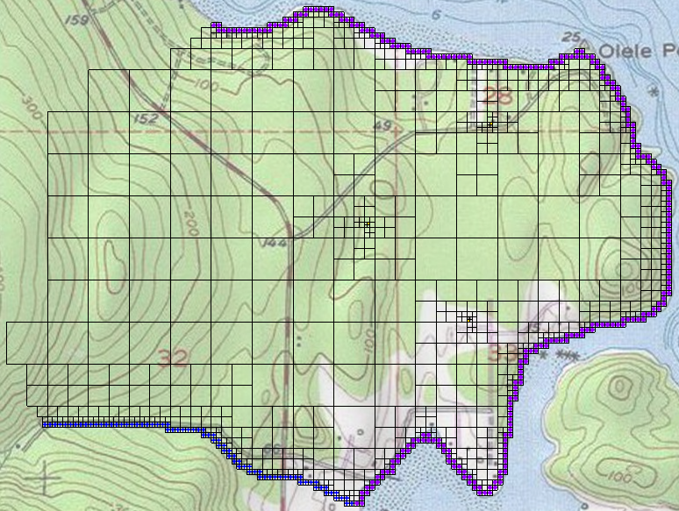

Figure 10 Quadtree UGrid with MODFLOW boundary conditions

## Save and Run MODFLOW

Now it is possible to run MODFLOW. At this point, it is a good idea to run the *MODFLOW Model Checker* to verify there are no obvious errors in the model.

1. Select *MODFLOW |* **Check Simulation…** to bring up the *Model Checker* dialog.
2. Click **Run Check**.

This command searches through the MODFLOW inputs for obvious errors such as negative values for hydraulic conductivity, and so on. The model should not have any warnings or errors.

1. Click **Done** to exit the *Model Checker* dialog.
2. **Save**  the project.
3. Click the **Run MODFLOW**  macro to bring up the *MODFLOW* model wrapper dialog.
4. When the model finishes, turn on *Read solution on exit* and *Turn on contours (if not on already)*.
5. Click **Close** to import the solution and close the *MODFLOW* dialog.

The Graphics Window should display contours similar to Figure 11. Notice that there is some drawdown around the wells.

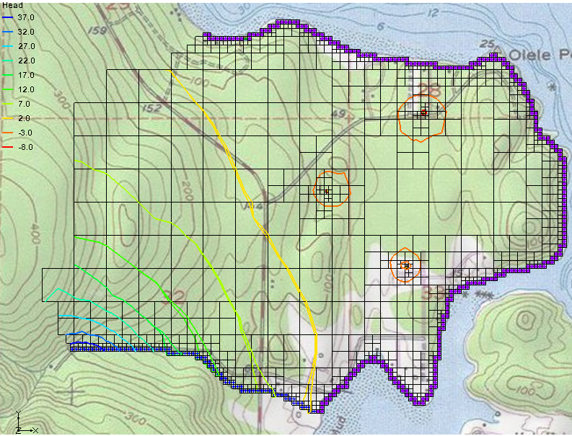

Figure 11 MODFLOW head contours

# Voronoi UGrids

## Create the 2D Voronoi UGrid

Next, create another MODFLOW-USG model using a Voronoi UGrid. Since all the model data is defined using the conceptual model approach, this process is fast. Follow the same procedure employed to create the 3D quadtree UGrid.

1. First, turn off “ quadtree-3d” to hide the 3D quadtree UGrid.
2. Expand the “ MODFLOW” conceptual model below the“ Map Data” item in the Project Explorer.
3. Right-click “ SourceSink” and select *Map To* **| UGrid** to bring up the *Map → UGrid* dialog.
4. From the *Dimension* drop-down, select “2D”.
5. From the *UGrid type* drop-down, select “Voronoi”.
6. Click **OK** to close the *Map → UGrid* dialog and generate the Voronoi UGrid.
7. Right-click on “ ugrid” and select **Rename**.
8. Enter “voronoi” and press *Enter* to set the new name.
9. Right-click on “ UGrid Data” and select **Display Options…** to open the *Display Options* dialog.
10. Select “UGrid: voronoi – [Active]” from the list on the left.
11. Check on *Define UGrid specific options*.
12. Turn on *Cell faces* and turn off *Face contours*.
13. Click **OK** to exit the *Display Options* dialog.

Figure 12 shows the Voronoi grid refined around wells and boundary conditions.

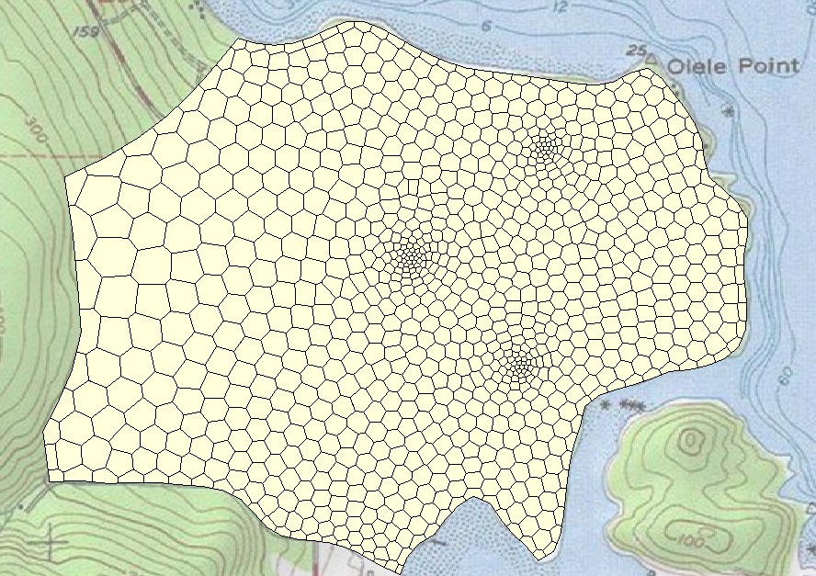

Figure 12 2D Voronoi UGrid

## Create a 3D Voronoi UGrid

It is now possible to create the 3D Voronoi UGrid.

1. Select the “ Borehole Data” folder in the Project Explorer to make it active.
2. Select *Boreholes |* **Horizons → UGrid…**to bring up the *Horizons Elevations* page of the *Horizons to UGrid* dialog.
3. Click **Next >** to go to the *Top and Bottom Elevations* page of the *Horizons to UGrid* dialog.
4. In the *Primary UGrid* section, select “ voronoi”.
5. Click **Finish** to close the *Horizons to UGrid* dialog and create the 3D UGrid.
6. Turn off “ voronoi” in the Project Explorer to hide the 2D UGrid.
7. Right-click on “ voronoi (2)” and select **Rename**.
8. Enter “voronoi-3d” and press *Enter* to set the new name.
9. Switch to **Oblique View**  to view the UGrid in 3D.

A 3D Voronoi grid similar to Figure 13 should now be visible. This grid looks similar to the 3D quadtree UGrid. View the different layers of this UGrid using the single layer viewing option (just as with the 3D quadtree UGrid).

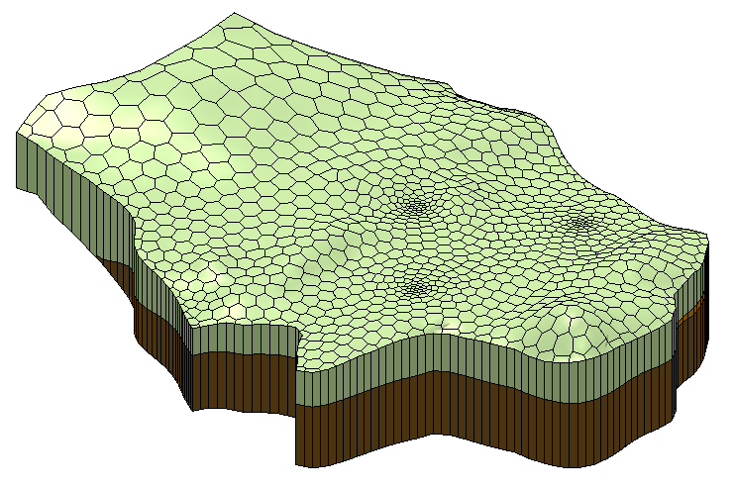

Figure 13 3D Voronoi UGrid

## Create a MODFLOW-USG Model

To create the MODFLOW-USG model:

1. Right-click on “ voronoi-3d” and select **New MODFLOW…**to open the *MODFLOW Global/Basic Package* dialog.
2. Click **OK** to accept the defaults and exit the *MODFLOW Global/Basic Package* dialog.

To define the aquifer properties for this model as done previously:

1. Select *MODFLOW |* **LPF - Layer Property Flow…** to open the *LPF Package* dialog.
2. In the *Layer property entry method* section, select *Use material IDs*.
3. Click **OK** to exit the *LPF Package* dialog.

## Map to MODFLOW

To assign the conceptual model values to the MODFLOW model:

1. Select the “ MODFLOW” conceptual model to make it active.
2. Select *Feature Objects |* **Map → MODFLOW** to bring up the *Map → Model* dialog.
3. Click **OK** to accept the defaults and close the *Map → Model* dialog.
4. Right-click on “ UGrid Data” and select **Display Options…** to open the *Display Options* dialog.
5. Select “UGrid: voronoi-3d – [Active]” from the list on the left.
6. Check on *Define UGrid specific options*.
7. Turn off *Cell faces*.
8. Click **OK** to exit the *Display Options* dialog.
9. Turn off “voronoi”.
10. Switch to **Plan View** .

Boundary condition symbols for specified head, rivers, and wells should appear similar to Figure 14.

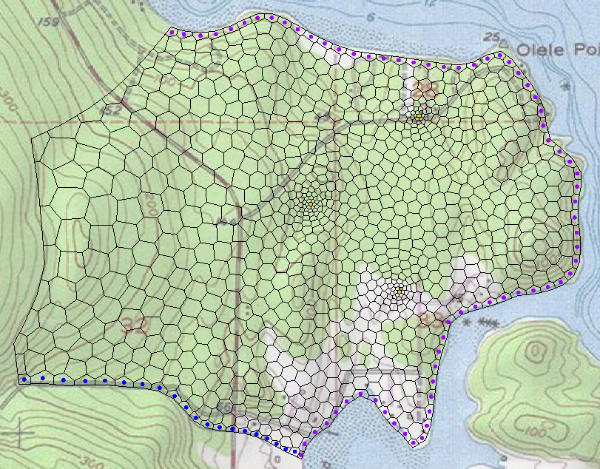

Figure 14 MODFLOW boundary conditions on a Voronoi UGrid

## Save and Run MODFLOW

Now it is possible to run MODFLOW.

1. **Save**  the project.
2. Click the **Run MODFLOW**  macro to bring up the *MODFLOW* model wrapper dialog.
3. When the model finishes, turn on *Read solution on exit* and *Turn on contours (if not on already)*.
4. Click **Close** to import the solution and close the *MODFLOW* dialog.

The contours should appear similar to Figure 15. Feel free to compare this solution with the previous ones.

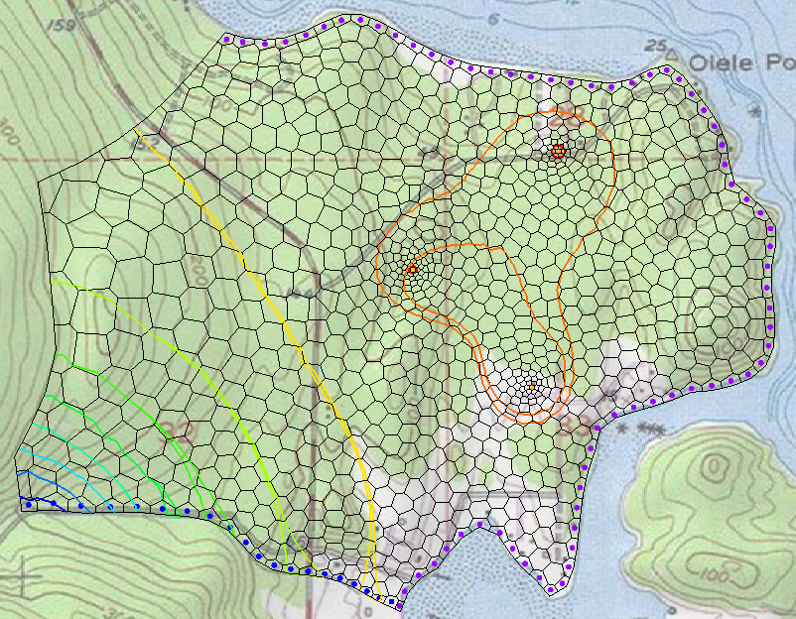

Figure 15 MODFLOW computed head contours on Voronoi UGrid

# VTK Unstructured Grids

## Import the VTK Unstructured Grid File

In the last part of this tutorial, a VTK unstructured grid matching the site boundary will be imported. The horizons will then be converted to make a 3D UGrid for the site.

1. Turn off “ voronoi-3d” in the Project Explorer to hide the UGrid.
2. Click **Open**  to bring up the *Open* dialog.
3. Select “All Files (*.*)” from the *Files of type* drop-down.
4. Browse to the *ComplexStratigraphy\ComplexStratigraphy* directory and select “tri-quad.vtu”.
5. Click **Open** to import the file and exit the *Open* dialog.

The UGrid should be similar to the one in Figure 16. VTK unstructured grids are very flexible and can contain many different types of cells (1D, 2D, 3D). The **Horizons → UGrid** command will work with any UGrid that contains only 2D cells. This particular UGrid contains only triangles and quadrilaterals.

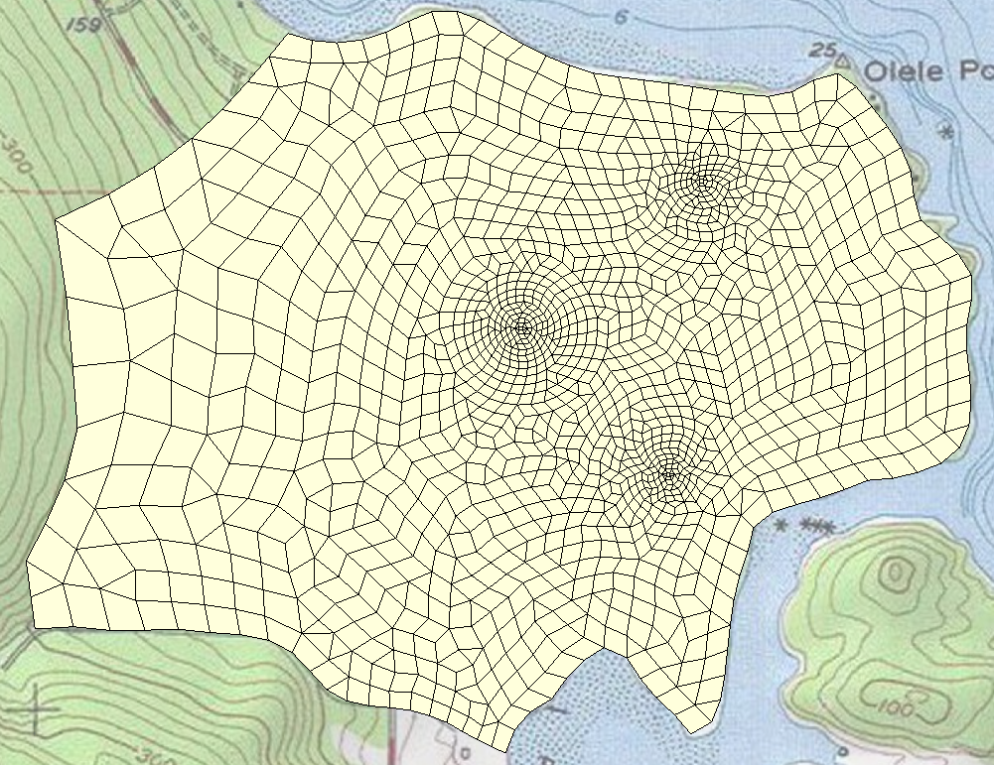

Figure 16 UGrid comprising triangle and quadrilateral cells

## Create a 3D UGrid

It is now possible to create the 3D UGrid.

1. Select “ Borehole Data” in the Project Explorer to make it active.
2. Select *Boreholes |* **Horizons → UGrid…**to bring up the *Horizon Elevations* page of the *Horizons to UGrid* dialog.
3. Click **Next >** to go to the *Top and Bottom Elevations* page of the *Horizons to UGrid* dialog.
4. In the *Primary UGrid* section, select “ tri-quad” and click **Finish** to close the *Horizons to UGrid* dialog.
5. In the Project Explorer, uncheck “ tri-quad”.
6. Right-click on “ tri-quad (2)” and select **Rename**.
7. Enter “tri-quad-3d” and press *Enter* to set the new name.
8. Right-click on “ UGrid Data” and select **Display Options…** to bring up the *Display Options* dialog.
9. Select “UGrid: tri-quad-3d – [Active]” from the list on the left.
10. Click on *Define UGrid specific options*.
11. Turn on *Cell faces* and turn off *Face contours*.
12. Click **OK** to exit the *Display Options* dialog.
13. Switch to **Oblique View**  to view the UGrid in 3D.

The 3D UGrid should be similar to Figure 17. This grid looks similar to the previously created 3D UGrids. Feel free to view the different layers of this UGrid as done with the previous ones.

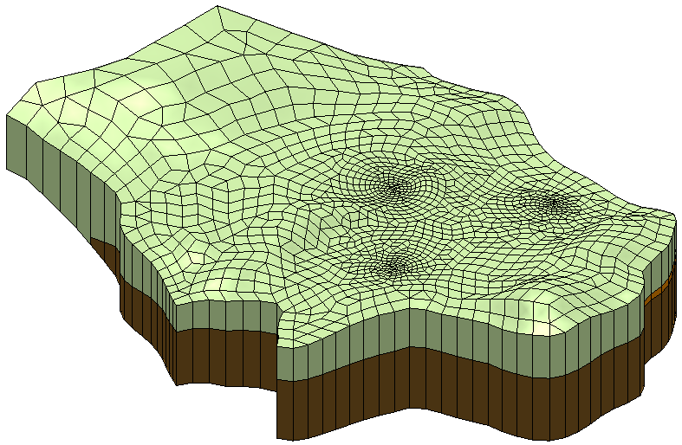

Figure 17 3D UGrid created from tri-quad 2D UGrid

## Create a MODFLOW-USG Model

To create the MODFLOW-USG model:

1. Right-click on “ tri-quad-3d” and select **New MODFLOW…**to bring up the *MODFLOW Global/Basic Package* dialog.
2. Click **OK** to accept the defaults and exit the *MODFLOW Global/Basic Package* dialog.

Next, define the aquifer properties for this model as done previously.

1. Select *MODFLOW |* **LPF - Layer Property Flow…** to open the *LPF Package* dialog.
2. In the *Layer property entry method* section, select *Use material IDs*.
3. Click **OK** to exit the *LPF Package* dialog.

## Map to MODFLOW

To assign the conceptual model values to the MODFLOW model:

1. Select the “ MODFLOW” conceptual model to make it active.
2. Select *Feature Objects |* **Map → MODFLOW**to bring up the *Map → Model* dialog.
3. Click **OK** to accept the defaults and exit the *Map → Model* dialog.
4. Right-click on “ UGrid Data” and select **Display Options…** to bring up the *Display Options* dialog.
5. Select “UGrid: trid-quad-3d – [Active]” from the list on the left.
6. Make sure *Display UGrid specific options* is turned on.
7. Turn off *Cell faces* and click **OK** to close the *Display Options* dialog.
8. Switch to **Plan View** .

Boundary condition symbols for specified head, rivers, and wells should appear, similar to Figure 18.

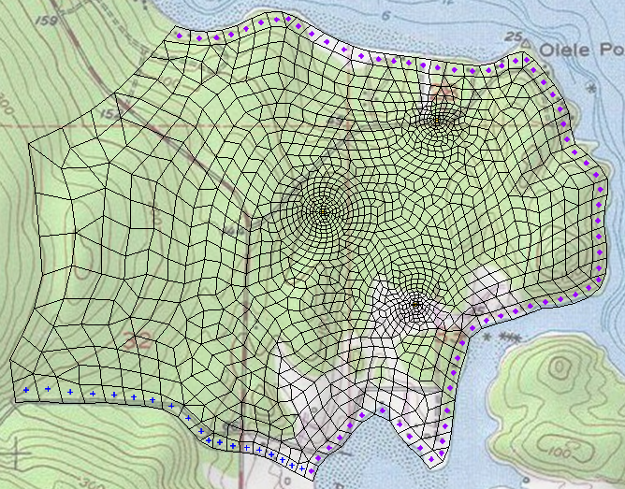

Figure 18 MODFLOW boundary conditions on a 3D UGrid

## Save and Run MODFLOW

Now it is possible to run MODFLOW.

1. **Save**  the project.
2. Click the **Run MODFLOW**  macro to bring up the *MODFLOW* model wrapper dialog.
3. When the model finishes, turn on *Read solution on exit* and *Turn on contours (if not on already)*.
4. Click **Close** to import the solution and close the *MODFLOW* dialog.

The contours should be similar to those in Figure 19. Feel free to compare this solution with the others in the tutorial.

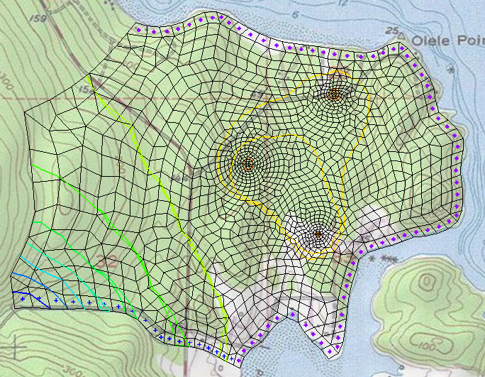

Figure 19 MODFLOW computed head contours on 3D UGrid

# Conclusion

This concludes the “MODFLOW – USG Complex Stratigraphy” tutorial. The following key concepts were discussed and demonstrated in this tutorial:

* The **Horizons → UGrid** command can create 3D UGrids of complex stratigraphy.
* The **Horizons → UGrid** command can create a variety of 3D UGrids.
* The **Horizons → UGrid** command will work on imported VTK unstructured grids that are comprised of 2D cells.
* Multiple UGrids and multiple MODFLOW-USG simulations can exist in the same GMS project.

1. Panday, Sorab; Langevin, Christian D.; Niswonger, Richard G.; Ibaraki, Motomu; and Hughes, Joseph D., (2013). “MODFLOW-USG version 1: An Unstructured Grid Version of MODFLOW for Simulating Groundwater Flow and Tightly Coupled Processes Using a Control Volume Finite-Difference Formulation” in *Techniques and Methods 6–A45*, U.S. Geological Survey, pp. 38–39. <https://pubs.usgs.gov/tm/06/a45/pdf/tm6-A45.pdf>.
2. The size will not be exactly 500 because the grid frame defines the extents of the grid. If the cells need to be exactly 500 feet square, adjust the extents of the grid frame to be a multiple of 500.
3. Grid refinement is explained in the “MODFLOW-USG – Quadtree” tutorial.